Programs and Recursive Functions

Church’s Thesis
- Collection of functions computed by an algorithm is the same as that computed by a Turing Machine
- Computer programs look like algorithm. Hence functions computed by computer is same as that by Turing Machine.
- Implemented by Universal Turing Machine

Complexity Classes

P Problem
- Number of steps is bounded by a polynomial.
- Produce correct answer for any input string of length n in at most n^{k} steps, where k is s constant independent of n.
e.g., Merge sort, Quick sort etc.

NP Problem
- Verifiable in polynomial time by a nondeterministic Turing machine. (A non deterministic Turing machine is a "parallel" Turing machine which can take many computational paths simultaneously, with the restriction that the parallel Turing machines cannot communicate.)
- A P-problem is always also NP. If a problem is known to be NP, and a solution to the problem is somehow known, then demonstrating the correctness of the solution can always be reduced to a single P verification.
- If P and NP are not equivalent, then the solution of NP-problems requires (in the worst case) an exhaustive search.

NP- hard
- An algorithm for solving the problem can be translated into one for solving any other NP-problem.

NP-Complete
- A problem which is both NP and NP-hard.
- Hardest of NP problems.

NP Complete Examples

- Circuit Satisfiability
Given a Boolean combinational circuit composed of AND, OR and NOT gates, is the circuit satisfiable (output is 1).

CIRCUIT-SAT = { <C> : C is a satisfiable boolean combinational circuit.>

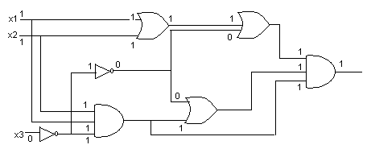
The above problem cannot be solved in polynomial time but can be verified. Hence it belong to NP category.

- Formula Satisfiablility
- Given a boolean formula circuit, is the formula satisfiable (output is 1).
  - Given right certificates, can be verified in polynomial time. Hence problem is NP.
  - To prove this to be NP-complete, reduce CIRCUIT-SAT to this. CIRCUIT-SAT p FORMULA-SAT

Steps
    - Name all output lines.
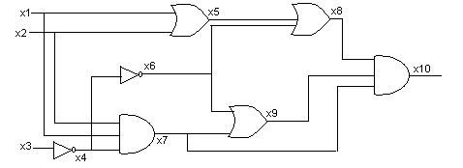

    - Find AND of all output lines.
φ = x₁₀ of (x₄ x₃)
(x₅ (x₁ x₂))
(x₆ x₄)
(x₇ (x₁ x₂ x₄))
(x₈ (x₅ x₆))
(x₉ (x₆ x₇))
(x₁₀ (x₇ x₈ x₉))

- 3 CNF Satisfiability
- Given a boolean formula is in CNF, if it ie expressed as an AND of clauses, each of which is the OR of one or more literals. A boolean formula is in 3-CNF, if each clause has exactly three literals. And satisfiable if output is 1.
  - Given right certificates, can be verified in polynomial time. Hence problem is NP.
  - To prove this to be NP-complete, reduce FORMULA-SAT to this. FORMULA-SAT p 3-CNF-SAT

Steps
φ = ((x₁x₂) ((x₁x₃)x₄))x₂

    - Create parse tree
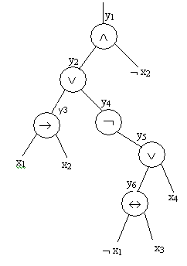
    - Create truth table
Find the truth value for each output line. For example, truth value for the first line can be written as
φ₁’ = y₁ (y₂ x₂)

y₁ | y₂ | x₂ | y₁ (y₂ x₂)
1 | 1 | 1 | 0
1 | 1 | 0 | 1
1 | 0 | 1 | 0
1 | 0 | 0 | 0
0 | 1 | 1 | 1
0 | 1 | 0 | 0
1 | 0 | 1 | 1
0 | 0 | 0 | 1

φ₁’’ = (y₁ y₂ x₂) (y₁ y₂ x₂) (y₁ y₂ x₂) (y₁ y₂ x₂)

Applying de Morgan’s law
φ₁’’’ = (y₁ y₂ x₂) (y₁ y₂ x₂) (y₁ y₂ x₂) (y₁ y₂ x₂)

Similarly find all φ_{i}’’’s and find the AND of all φ_{i}’’’s.

    - If all clauses has three distinct literals, select all. Else
      - If all clause contain two distinct literal, introduce new literal p. Add two more clauses
(l₁ l₂ p) and (l₁ l₂ p)
      - If all clause contain only one literal, introduce two new literals p and q. Add four more clauses
(l₁ p q), (l₁ p q), (l₁ p q)and (l₁ p q)

- Clique problem
- Clique in an undirected graph G = (V, E) is a subset V’  V of vertices, each pair of which is connected by an edge in E. In other words, a clique is a complete graph. The size of a clique is the number of vertices it contains. The clique problem is the optimization problem of finding a clique of maximum size in a given graph.
- CLIQUE = { <G, k> : G is a graph with a clique of size k }
- To prove this to be NP-complete, reduce 3-CNF-SAT to this. 3-CNF-SAT CLIQUE.
Steps

φ = ( x₁ x₂ x₃ ) (x₁ x₂ x₃ ) ( x₁ x₂ x₃ ) x₁ = 0, x₂ = 0, x₃ =1

    - Let φ be a Boolean expression with k clauses. Construct a graph G such that φ is satisfiable if and only if graph has a clique of size k.
    - Graph can be constructed as
      - For each clause C_{r} = (l₁^{r} l₂^{r} l₃^{r}) in φ, place a triple of vertices v₁^{r}, v₂^{r} , v₃^{r} into V. Put an edge between two vertices if both of the following hold.
        - v_{i}^{r} and v_{j}^{r} are in different triples, that is, rs, and
        - their corresponding literals are consistent, that is, l_{i}^{r} is not the negation of l_{j}^{s}
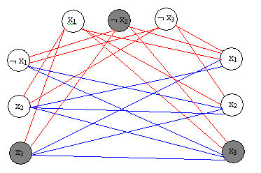
    - Each C_{r} contains at least one literal l_{i}^{r} that is assigned a, each such literal corresponds to vertex v_{i}^{r}. Pick one such literal from each clause yields a set V’ of k vertices.

- Vertex cover problem
- Vertex cover in an undirected graph G = (V, E) is a subset V’ V such that if (u,v) V’, then u V’ or v V’ or both. The clique vertex cover problem is to find a vertex cover of minimum size in a given graph.
- VERTEX-COVER = { <G, k> : G has a vertex cover of size k }
- To prove this to be NP-complete, reduce 3- CLIQUE to this. Reduce CLIQUE VERTEX-COVER

Steps
    - Given G = (V, E), V’ V where V’ is a clique.
    - Find complement of G, G’ = (V,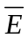), where = {(u,v) : u,v V, u v and (u,v) E }
as graph formed by all edges not in G
    - Take an edge (u,v) in G’. Either u or v or both are not present in V’. Hence vertices not present in V’ form cover of G’.
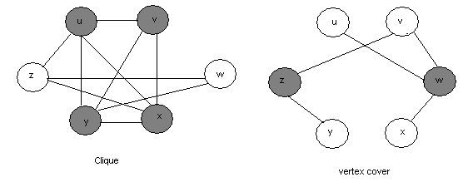

- Subset sum Problem
- Finding what subset of a list of integers has a given sum .
- SUBSET-SET SUM = { <s,t> : there exists a subset S’ S such that t = 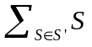
- Reduce 3-CNF-SAT SUBSET-SUM

Assumptions
- No clasuse contains variable and its completment ( x_{i} and 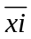)
- Include all variables in every clause

e.g. Given a 3-CNF-SAT equation
φ = (x₁ 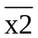 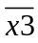) ( 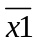) ( x3) (x₁ x2x3)

Steps
- Add 2 numbers for each varioables and clauses.
- Form numbers consisting of n+k digits, where n is the number of varioables and k is the number of clauses
- Form target as a number of the form 111…444…. Where number of 1’s equal to number of variables and number of 4’s eqaul to number of clauses.

Table created for φ is given below.
 | x₁ | x₂ | x₃ | c₁ | c₂ | c₃ | c₄
v₁ | 1 | 0 | 0 | 1 | 0 | 0 | 1
v₁' | 1 | 0 | 0 | 1 | 1 | 1 | 1
v₂ | 0 | 1 | 0 | 0 | 0 | 0 | 1
v₂' | 0 | 1 | 0 | 1 | 1 | 1 | 0
v₃ | 0 | 0 | 1 | 0 | 0 | 1 | 1
v₃' | 0 | 0 | 1 | 1 | 1 | 0 | 0
S₁ | 0 | 0 | 0 | 1 | 0 | 0 | 0
S₁' | 0 | 0 | 0 | 2 | 0 | 0 | 0
S₂ | 0 | 0 | 0 | 0 | 1 | 0 | 0
S₂' | 0 | 0 | 0 | 0 | 2 | 0 | 0
S₃ | 0 | 0 | 0 | 0 | 0 | 1 | 0
S₃' | 0 | 0 | 0 | 0 | 0 | 2 | 0
S₄ | 0 | 0 | 0 | 0 | 0 | 0 | 1
S₄' | 0 | 0 | 0 | 0 | 0 | 0 | 2
Target | 1 | 1 | 1 | 4 | 4 | 4 | 4

S’ can be created as :
- If x_{i} = 1 pick v_{i} else v_{i}’.
In above example select v₁’, v₂’, v_{3.}
They will add 1’s to digit corresponding to variables and maximum of 3 to digits corresponding to variables.
- Select appropriate slack S_{i}’s to make sum as 4 for clauses.
In above example select S_{1,} S₁’, S_{2,} S₂’, S_{3,} S_{4,} S₄’.
Hence we have S’ = { v₁’, v₂’, v_{3,} S_{1,} S₁’, S_{2,} S₂’, S_{3,} S_{4,} S₄’}

So we proved that we can reduce 3-CNF-SAT to Subset-Sum problem.
But 3-CNF-SAT is NP-Complete hence Subset-Sum problem is also NP-Complete.

